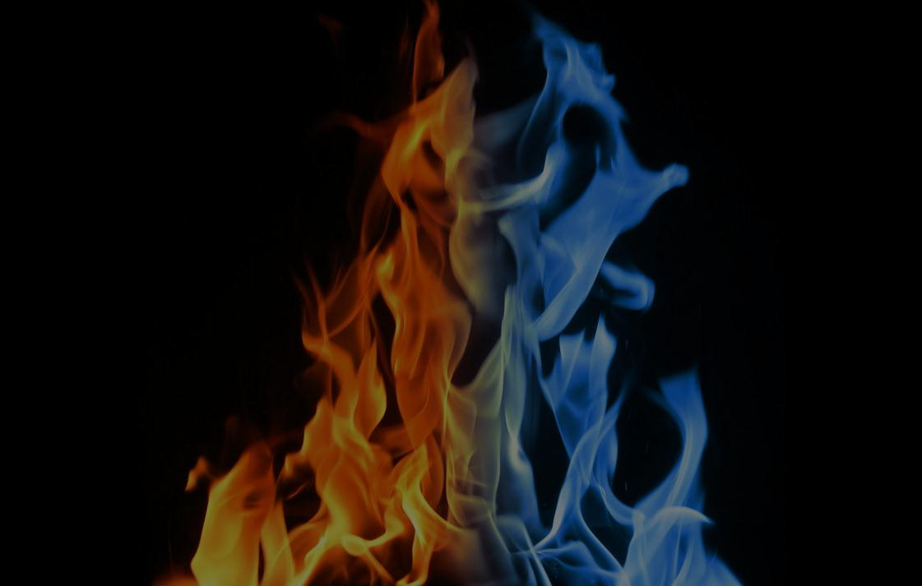

**NORTH AMERICAN**

**FORENSICS SOCIETY**

**“Fire & Ice” CONTINENTAL CHALLENGE**

**(IE, IPDA, NPDA “PARLI” & NFA-LD)  
The Caribe Royal, Orlando, Florida**

**Dear Forensic Friends**

Bowling Green State University and Tallahassee Community College Forensics Teams cordially invite you to attend a rich forensics experience on **January 17-18, 2014, the NORTH AMERICAN FORENSICS SOCIETY:**

**“Fire & Ice” CONTINENTAL CHALLENGE. Visit our tournament web site at:**

<http://falcontournaments.weebly.com/north-american-forensics-society-orlando.html>

**This forensics and debate event offers teams an international and cultural experience close to home at a reasonable price wrapped around a hybrid forensics tournament. Each season, the NAFS rotates between the fire and warmth of south of the border and the icy fun of the great white north. The hotel style tournament, based on the successful Pi Rho Pi and Pi Kappa Delta models, offers 2 rounds of quality competition in all 11 AFA-NIET IE events, IPDA,** NFA-LD & NPDA/PARLI Debate in a 4 round + appropriate eliminations format, plus a fun experimental category which changes with the location. Collector medals reflecting each location are the awards for all finalists as well as engraved trophies for the top teams. The NAFS is not a league and does not require membership. It is open to all members of our forensics community.We hope you will include us in your 2013-2014 tournament plans!

**Orlando 2014**

**Our tournament heads to the warmth of the south this season to visit the amazing city of Orlando, Florida. From cultural events to museums, the beach, a thriving nightlife, Universal Studios, Disney USA , Seaworld Orlando and water parks, Orlando has it all! We look forward to hosting you in January!**

|  |  |
| --- | --- |
| **Paul Wesley Alday,** Director of Forensics & Debate  Bowling Green State University  School of Media & Communication  302 West Hall, Bowling Green, OH 43403-0236  TELEPHONE: 419.372.8856  E-mail address: [BGSU4N6@yahoo.com](mailto:BGSU4N6@yahoo.com) | **John Schultz,** Director of Forensics Tallahassee Community College  Department of Theatre  444 Appleyard Drive, Tallahassee, FL 32304 TELEPHONE: 850.201.8037 E-mail address: [SCHULTZJ@tcc.fl.edu](https://webmail.tcc.fl.edu/owa/UrlBlockedError.aspx" \t "_blank) |

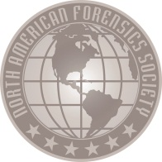

**NORTH AMERICAN**

**FORENSICS SOCIETY**

**“Fire & Ice” CONTINENTAL CHALLENGE**

**ORLANDO, FLORIDA**

Orlando is a clean, safe, cosmopolitan city with a wonderful network of parks, recreational, and cultural facilities. It is the home of a variety of world-class attractions, including: Walt Disney World, Epcot, Downtown Disney, Ripleys, Universal Studios, Seaworld Orlando and the warm Florida sun. This city which once began as a quiet farming town is now one of the largest destinations globally.

|  |  |  |
| --- | --- | --- |
|  | **Walt Disney World**  **Kissimmee St. Cloud**  **Cirque du Soleil**  **Harry P. Leu Gardens**  **Encantada Golf Course**  **Epcot Center**  **Gatorland USA** |  |
| **Universal Studios Orlando**  **Orlando Ballet**  **Typhoon Lagoon Water Park**  **Arnold Palmer’s Bay Hill Club**  **Orlando Science Center**  **Daytona Intl Speedway**  **Kennedy Space Center** |  | **Ripleys Believe it or Not**  **ESPN World Sports Complex**  **Downtown Disney**  **Disney Animal Kingdom**  **The Island Spa**  **Annie Russell Theatre**  **Orlando Museum of Art** |

*Yahoo Travel website* <http://travel.yahoo.com/p-travelguide-191501911-orlando_vacations-i?showmore=1>

*Visitorlando.com* <http://www.visitorlando.com/>

Want to know more about Orlando? Available for iPhone, Android, Blackberry and Windows Phone, the app provides tips on things to see and do including easy-to-search event, dining, attractions and shopping listings.

**TRANSPORTATION**

Orlando is easily accessible by air, rail and road.

By air, the Orlando International Airport is Orlando’s largest airport, just 6 miles from the downtown city area and our tournament hotel by Mears hotel shuttle. It is the main hub for Southwest and Jet Blue airlines and is also served by most major carriers, so direct flights from most US cities keep prices down. Several smaller airports are also within an hour drive, including, Orlando Sanford International Airport, Orlando Executive Airport, Kissimmee Gateway Airport and Melbourne International Airport.

By Amtrak has 9 station stops in Orlando and the surrounding area for convenient and easy access.

By car, Orlando sits directly on one of Florida’s main highways, Highway 192.

**HOTEL INFORMATION**

|  |  |
| --- | --- |
| NAFS participants stay at:  ***The Caribe Royal***  ***8101World Center Drive***  ***Orlando, Florida***  ***PHONE 407.238.8035***  This is a hotel tournament, based on Pi Rho Pi and Pi Kappa Delta Nationals, where competition rounds are held in the guest rooms. Each school is required to make available 2 rooms at the Caribe Royal during the tournament (covering up to 20 slots). Larger entries will be expected to provide additional rooms (1 additional room per every additional 10 slots). All competition rooms must be available for all rounds and groupings throughout the competition, even if a school is not entered in that grouping.  Rooms will be securely accessed only with a judge present and every effort will be made to place judges from schools providing the space in their own rooms. |  |

An ALL SUITE HOTEL! The hotel is holding a block of rooms for “NAFS” until January 2, 2014. After this date, rooms can still be reserved at the group rate, based on availability. The special NAFS rate (which is the LOWEST rate available at the hotel) can be reserved via the Caribe Royal website at:

<http://www.cariberoyale.com/> and by phone: 407.238.8035. Please ask for the “North American Forensics Society” event.

Be sure to book your rooms as early as possible. If the guest room block gets full, we will ask the hotel for additional rooms and there needs to be ample time to do this. The NAFS block of rooms runs from January 17-18. For the convenience of those wishing to come early or stay beyond the tournament, special arrangements have been made to extend our group room rate to 3 days before and after our event. The rate per night is $139 USD + taxes for single or double occupancy. Our rate includes complimentary access to the in-house fitness center & pool, high speed internet access and daily newspaper. *A credit card number is needed to hold the rooms, but will* NOT be charged until the day you check out of the hotel.

The Caribe Royal is an All-Suite Hotel and Convention Center, business and pleasure go hand in hand. From the very beginning, the facility redefined and elevated the standards of the meeting, conference and family vacation experience in Florida. Here among more than 53 lush, tropical acres, guests will discover 1,218 spacious, well-appointed one-bedroom suites, 120 luxurious two-bedroom lakeside villas, expansive state-of-the-art meeting and event facilities, and a wealth of dining options and amenities.

Visit <http://www.cariberoyale.com/> for more information!

**TOURNAMENT INFORMATION**

**TOURNAMENT FEATURES**

* Two preliminary rounds and finals of competition in All 11 NFA/AFA-NIET IE events.
* NFA-LD, IPDA & NPDA Debate in open and novice divisions as warranted by entry size.
* WALT DISNEY INTERPRETATION (WDI) as our experimental event.
* Collectable medals for the top six finalists per even; engraved crystal trophies for the top four in Quadrathon and top three IE & Debate Teams.
* Unlimited team entry per event, debate cross entry with IE & students may quad enter per flight!
* Relaxed scheduling with snack breaks and evenings off to enjoy the city.
* An experienced tournament staff, assuring a smooth running and positive experience.

**AWARDS**

Finalists per event earn custom medals. Each NAFS event will have its own custom minted medal unique to that location, making them a keepsake as well as an honor; The top three 4 year teams, the top three junior college teams and top four in Quadrathon in IE receive trophies. The top 3 Debate Teams receive sweepstakes trophies as well. The top 2 scores per IE event will be used to calculate team sweepstakes, all finalists earn points. Debate will not be included in IE sweepstakes consideration.

|  |  |
| --- | --- |
| **Preliminary Rounds** | **Elimination Rounds** |
| 1st place = 3 pts  2nd place = 2 pts  3rd place = 1 pt  No additional points awarded for semi-final rounds | 1st place = 12 pts  2nd place = 10 pts  3rd place = 8 pts  4th place = 6 pts  5th place = 4 pts  6th place = 2 pts  7th place = 1 pt (if unbreakable tie took 7 to finals) |

**QUADRATHON**

Any student entered in four or more events will be eligible for Quadrathon Individual Sweepstakes. A Quadrathon entry must contain at least one public address, one limited preparation and one interpretation event. Note on the entry form if a participant qualifies. Only the contestant’s four highest scoring events will count toward Quadrathon. Debate will not be included in Quadrathon consideration.

**ENTRIES**

Schools may enter an unlimited number of contestants per event. However, if the entry is so large that the school cannot fulfill judging obligations, we reserve the right to schedule rounds to use all judges. Depending on size, students from the same school may compete against each other. Registration will be available on Thursday evening; late registration begins at 7:00 am., both in the Lobby. NFA-LD, IPDA & NPDA/PARLI round I begins at 8:00 am., Extemp. draw at 11:00 am. and IE Rounds at 11:30 am.

|  |
| --- |
| **Entries must be phoned or e-mailed by Monday, January 6, 2014 at 4:00pm EST**  **Send entries for both tournaments to** [BGSU4N6@Yahoo.com](mailto:BGSU4N6@Yahoo.com)  **All schools will receive a confirmation email.** |

**JUDGING**

One judge is required for every 6 IE slots or fraction thereof or 2 debate slots. Judges are expected to be knowledgeable of rules and are asked to offer substantial justification for rank and rate. Please attempt to bring enough judges to cover your entry. All judges (including debate) are expected to be available for all out rounds. Debate entries are required to provide sufficient judges to cover a minimum of 50% of the debate entry and debate judges will be entered into a general judging pool for all debate forms.  
  
**TOURNAMENT FEES**

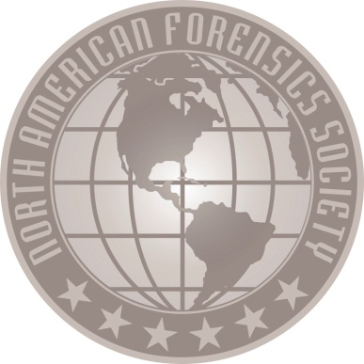Entries are $8.00 per IE slot, plus $12.00 per uncovered slot and $55.00 per debate slot, plus $75 per uncovered slot. Drops/adds/changes made after the registration deadline are assessed an additional $15.00 nuisance fee. There is a $75 tournament fee per school to help offset the cost of conference facilities for extemp prep, the debate warm room, tab and awards. Judges dropped after the entry deadline will be assessed a $100.00 charge, plus the cost of their uncovered slots. All fees are due at registration. *Checks may be made out to “Pi Kappa Delta”*.

**TOURNAMENT SCHEDULE**

**Registration: Thursday evening 8:00-9:00pm in the Lobby.**

**Teams will be required to submit 1 copy of key cards for each provided competition room at this time.**

**The required number of rooms for each school will be included in their tournament confirmation.**

|  |  |  |  |
| --- | --- | --- | --- |
|  | **Friday (January 18)** |  | **Saturday (January 19)** |
| **7:00 – 9:00** | Late Registration **(Lobby)**  Debate Registers at 7:00am |  |  |
| **8:00** | Topic Release **(Warm Room)** | **8:00** | Topic Release **(Warm Room)** |
| **8:15** | IPDA/NPDA/LD Round 1 | **8:15** | IPDA/NPDA/LD Round 4 |
| **9:30** | Topic Release **(Warm Room)** | **9:30** | Finals Extemp. Draw **(Warm Room)** |
| **9:45** | IPDA/NPDA/LD Round 2 | **10:00** | **Finals** of **Group A** |
| **11:00** | Extemp. Draw **(Warm Room)** | **11:30** | **Finals** of **Group B** |
| **11:30** | R1 of **Group A** | **12:45** | Topic Release **(Warm Room)** |
| **1:00** | Extemp. Draw **(Warm Room)** | **1:00** | IPDA/NPDA/IPDA/LD **Finals** |
| **1:30** | R2 of **Group A** | **3:00** | Awards |
| **3:00** | Topic Release **(Warm Room)** |  |  |
| **3:15** | IPDA/NPDA/LD Round 3 | **TAB ROOM** | **TBA** |
| **4:30** | R1 of **Group B** | **Debate/EXT** | **TBA** |
| **5:30** | R2 of **Group B** | **Awards** | **TBA** |

**NOTES**

IPDA/NPDA/PARLI topics will alternate between propositions of fact, policy and value. Hybrid NPDA/PARLI teams are a possibility and will count 50% towards Debate Team Sweepstakes. The 10 minute forfeiture policy will be in effect for LD debate. IPDA/NPDA/PARLI forfeiture is based on round start times as announced at topic release. All judges will be instructed to close out the round at the end of the scheduled time. Debate round I begins promptly at 8:15am. Teams arriving/registering late will forfeit this round. Oral critiques and disclosure are not allowed for any rounds (including elimination).

**IE EVENT GROUPINGS**  
**Group A**  
Extemporaneous Speaking, Prose Interpretation, Informative Speaking, Poetry Interpretation, Communication Analysis & Walt Disney Interpretation

**Group B**  
Impromptu Speaking, Duo Interpretation, Persuasion, Programmed Oral Interpretation, After Dinner Speaking & Dramatic Interpretation

**EVENT DESCRIPTIONS**

IE events are governed by a combination of NFA & AFA/NIET rules <http://www.americanforensics.org/> , with the exception of the experimental event. Material and speeches must be new to the academic year. Students may enter a maximum of three events per grouping. Two DUOs count as two events in Group B.

[EXT] EXTEMPORANEOUS SPEAKING   
For each round, contestants will select one of three topics on a current national, international, economic, or social issue/event. The contestant will have 30 minutes to prepare a 5-7 minute speech on the topic selected. Notes are permissible, but should be kept to a minimum. 7 minute maximum time limit.

[PRO] PROSE INTERPRETATION   
The contestant presents a program of prose literature. Original introductory comments and transitional remarks are permitted. Programs may consist of single or multiple selections in 1st, 2nd or 3rd person. Plays are not permitted and manuscript is required. 8-10 minute time limit.

[INF] INFORMATIVE SPEAKING  
The contestant delivers a memorized original factual speech on a realistic subject to fulfill a general information need of the audience. Visual/auditory aids which supplement/reinforce the message are permitted. 8-10 minute time limit.

[POE] POETRY INTERPRETATION  
The contestant presents a program of poetic literature. Original introductory comments and/or transitions are permitted. Programs may consist of single or multiple selections. Manuscripts are required. 8-10 minute time limit.

[RCA] RHETORICAL/COMMUNICATION ANALYSIS  
Contestants deliver a memorized original critical analysis of any significant communication event. Any legitimate critical methodology is permissible, as long as it serves to open up the communication event for analysis. 8-10 minute time limit.

[WDI] WALT DISNEY INTERPRETATION  
In celebration of Orlando’s connections with … well, all things Disney, contestants prepare an interpretive performance connecting with the Disney roots. The event may be any format of interpretive event. Manuscript is required and focus should be offstage. 8 minute maximum time limit.

[IMP] IMPROMPTU SPEAKING  
Contestants receive quotations and/or cartoons from which to create an analytical speech. A total of 7 minutes may be divided between preparation and speaking. Contestants should speak at least 3 minutes. All contestants in the same section will receive the same topic stimulus. Look for space-themed stimuli. 7 minute maximum time limit.

[DUO] DUO INTERPRETATION  
Contestants perform a cutting from a play or other material, humorous or serious, is presented by two individuals. This is not an acting event; thus, costumes, props, etc. are not permitted. Manuscript is required and focus should be offstage. 8-10 minute time limit.  
  
[PER] PERSUASION  
Contestants deliver an original memorized speech to convince, move to action, or to inspire on an issue of significance. 8-10 minute time limit.

[POI] PROGRAM ORAL INTERPRETATION  
A program of thematically linked selections of literary merit selected from at least 2 of the 3 genres of competitive interpretation (prose, poetry, drama). Nontraditional material may also be included. Original comments and/or transitions are permitted. Manuscripts are required. 8-10 minute time limit.

[ADS] AFTER DINNER SPEAKING  
Each contestant presents an original memorized speech with the purpose of making a serious point through the use of humor. The speech should reflect the spirit of a humorous, comedic speech, not a stand-up comedy routine. 8-10 minute time limit.

[SDI] SINGLE DRAMATIC INTERPRETATION  
Contestants present a cutting, which represents one or more characters from a play or plays of literary merit. This material may be drawn from stage, screen, or radio. Original introductory comments and/or transitions are permitted. Programs may consist of single or multiple selections. Manuscripts are required. 8-10 minute time limit.

*[IPDA] INTERNATIONAL PUBLIC DEBATE*

IPDA utilizes a one-on-one format in which one debater takes the side of the affirmative where they have the burden of advocating and proving the resolution, following IPDA rules ( http://www.ipdadebate.info/index.html ). The other debater takes the side of the negative where they refute the affirmative's case. For each round, the two debaters are given five possible resolutions. The negative begins the topic selection by striking one resolution, then the affirmative strikes one resolution. The negative strikes again. Thus, the affirmative has two resolutions to choose from. The affirmative then strikes one of the remaining resolutions, selecting the other as the topic for the round. After the topic has been selected, both debaters have thirty minutes to prepare a case.

[LD] NFA - LINCOLN/DOUGLAS DEBATE  
This is a two-person debate format following NFA rules ( **[http://www.nationalforensics.org/lincoln-douglas-debate/ld-rules](http://www.nationalforensics.org/lincoln-douglas-debate/ld-rules" \t "_blank)** ). Debaters must use the current NFA resolution. Lincoln/Douglas Debate is a policy-oriented debate focusing on stock issues of harm, inherency & solvency. Speakers will either alternate or flip for affirmative or negative speaker. Each LD debater has the option to save up to 1 minute of cross-examination time for use at the conclusion of any speech in the course of the debate. For LD, the 15 minute forfeit rule will be in force. Judges are asked to award the forfeit promptly at the appropriate time and note the forfeit on the ballot. The decision of the judge to award a forfeit shall be final. This season’s NFA Resolution is:

**Be it Resolved:  The USFG should substantially reform elementary and/or secondary education in the U.S.**

[NPDA] PARLIAMENTARY DEBATE  
This is a four-person team debate format following NPDA rules (<http://www.parlidebate.org/npda-rules/> ). Debaters are presented a different topic per round. NPDA Debate may focus on propositions of policy, value or fact as dictated by the topic. The Government affirms the topic and defines the parameters of the debate after a 15 minute prep period. The Opposition refutes the government’s position. Parliamentary procedure is incorporated into the debate with the opportunity for feedback from the peanut gallery. For NPDA, a 16 minute (from topic release) forfeit policy is in place. Judges are asked to award the forfeit promptly at the appropriate time and note the forfeit on the ballot. The decision of the judge to award a forfeit shall be final.

|  |  |
| --- | --- |
| **NFA-LD Debate** | **NPDA/PARLI Debate** |
| [6 MIN] 1st Affirmative Constructive  [3 MIN] Negative Cross Examination  [7 MIN] 1st Negative Constructive  [3 MIN] Affirmative Cross Examination  [6 MIN] 1st Affirmative Rebuttal [6 MIN] 1st Negative Rebuttal [3 MIN] 2nd Affirmative Rebuttal  [4 MIN] Prep. Time per Debater | [7 MIN] 1st Government Constructive (Prime Minister)  [8 MIN] 1st Opposition Constructive (Leader of the Opposition)  [8 MIN] 2nd Government Constructive (Member of Government)  [8 MIN] 2nd Opposition Constructive (Member of Opposition)  [4 MIN] Opposition Rebuttal (Leader of Opposition) [5 MIN] Government Rebuttal (Prime Minister)  [20 MIN] Prep. Time for the Government Team From Topic Release. |
| **IPDA Debate** |  |
| [5 MIN] Affirmative Constructive  [2 MIN] Negative Cross Examination  [6 MIN] Negative Constructive  [2 MIN] Affirmative Cross Examination  [3 MIN] Affirmative Rebuttal  [5 MIN] Negative Rebuttal  [3 MIN] Affirmative Rebuttal/Closing Remarks  [20 MIN] Prep. Time From Topic Draw. |  |