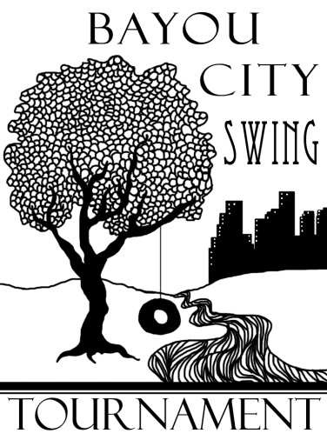

Dear Colleagues:

Lone Star College-North Harris and San Jacinto College North Forensics invite you to the Bayou City Swing, October 18-20, 2019. The swing is open to all intercollegiate competitors. Both halves of the swing will be held on the San Jacinto College North campus. Registration will take place in the Fine Arts Building. The tournament will offer NPDA, IPDA, NFA-LD in addition to all 11 AFA-NIET individual events. Dinner will be provided on Friday evening.

On Friday, 6 rounds of NPDA debate will be offered with quarters (or semis) on Friday as well. Semis (or finals) will be held on Saturday. There will be only one division offered. We will follow all NPDA rules and procedures. WiFi internet access should be available in the building’s common areas. Additionally, 5 rounds of IPDA and NFA-LD will be offered on Saturday. Competitors in IPDA or NFA-LD will not be able to cross enter for the first portion of the swing. We will follow all Phi Rho Pi IPDA and NFA-LD rules and procedures. The tournament is unable to supply prep rooms for IPDA.

Saturday and Sunday will each be a self-contained IE tournament, with all 11 AFA-NIET Individual Events. There will be only one division offered. We will follow all AFA rules. No prepared event may have been used in competition prior to this academic year.

**ENTRIES**: Entries will be registered through Joy of Tournaments. The website is www.joyoftournaments.com. Fees will be calculated at 12:00pm on Tuesday October 15th. Adds or drops after 5:00pm on Wednesday October 16th are subject to regular fees as assessed on the 15th plus a nuisance fee. There is no limit on the number of students a school may enter per event. Students may enter no more than three events per pattern. Students entered in multiple events are responsible for notifying their judges, and judges will not wait past the scheduled times for students who are cross entered.

**JUDGES:** One judge can cover four (4) individual events slots per pattern for a total of 8 slots across the two patterns. Each debate judge covers two (2) debate teams. A very limited number of hired judges will be available for uncovered slots/teams.

**FEES:** Debate entry fees for the tournament are $50 per Parliamentary Debate team and $25 for IPDA and $35 for NFA-LD. NPDA judging fees are $75.00 per uncovered team. One judge covers two debate entries. IPDA judging fees are $40.00. One judge covers 2 IPDA debaters. NFA-LD judging fees are $50.00. One judge covers 2 NFA-LD debaters. IE entry fees for the tournament are $10.00 per slot per half. Each judge, as previously mentioned, covers four (4) individual event slots per pattern. Hired judges are an additional $12.00 per uncovered slot. Schools which drop judges after Wednesday October 17th at 5:00 PM will incur a $100.00 nuisance fee plus all fees for uncovered slots/teams. *Cash is the vastly preferred for payment of fees*. If you must pay by check, please make checks for both halves of the tournament payable to Wade Hescht.

**LODGING:** We will be using the La Quinta Inn located very conveniently to the campus at 5520 East Sam Houston Pkwy N, Houston, TX 77015 as our tournament hotel. They have guaranteed us a very reasonable rate of $89.99 per night plus tax. Please call 281-452-4402 to make reservations or for further information. Make sure to mention the BAYOU CITY SWING ROOM BLOCK. They will hold the block until October 10th. Please bring your tax exemption form if you do not wish to pay state tax.

We look forward to seeing you here in Houston in October!

Respectfully,

Wade Hescht  
Director of Forensics  
Lone Star College-North Harris

Floyd McConnell

Director of Forensics

San Jacinto College North Campus

**2019 Bayou City Swing**

**Tentative Debate Schedule**

**Friday – October 19, 2018**

11:30 am          **Tournament Registration** (Fine Arts Building)  
12:30 pm          **Rd 1** NPDA   
1:45 pm            **Rd 2** NPDA  
3:00 pm            **Rd 3** NPDA  
4:15 pm            **Rd 4** NPDA  
5:15 pm            **Dinner Break** (provided by tournament host)  
5:45 pm            **Rd 5** NPDA  
7:00 pm            **Rd 6** NPDA  
8:15 pm            **Elim 1** NPDA

**Saturday – October 20, 2018\***

7:00 am      **IE Registration** (Fine Arts Building)  
7:30 am          **Draw** (IPDA)  
8:00 am          **Rd 1** (IPDA, NFA-LD)   
9:30 am          **Draw** (IPDA)

10:00 am **Rd 2** (IPDA, NFA-LD)  
11:00 am          **Draw** (IPDA)  
11:30 am          **Rd 3** (IPDA, NFA-LD)  
12:30 pm          **Lunch Break**   
1:00 pm           **Draw** (IPDA)

1:30 pm **Rd 4** (IPDA, NFA-LD)

3:00 pm **Draw** (IPDA)

3:30 pm            **Elim 1** (IPDA, NFA-LD)

5:00 pm **Draw** (IPDA)

5:30 pm **Elim 2** (IPDA, NFA-LD) – if necessary

7:00 pm **Elim 2** (NPDA) – if necessary  
8:15 pm            **Awards Ceremony**  
ASAP               **Elim 3** (DEBATE) - if necessary

* IPDA competitors will not be allowed to enter Pattern A nor B for Saturday’s Tournament.

**2019 Bayou City Swing**

**Tentative IE Schedule**

**Saturday – October 20, 2018\***

7:00 am      **IE Registration** (Fine Arts Building)  
7:30 am          **Draw** (EXT)  
8:00 am          **Rd 1** (Pattern A**)   
9:30 am          **Rd 1** (Pattern B***)  
11:00 am          **Draw** (EXT)  
11:30 am          **Rd 2** (Pattern A)  
12:30 pm          **Lunch Break** (on your own)

1:30 pm **Rd 2** (Pattern B)

3:00 pm **Draw** (EXT)

3:30 pm            **Finals** (Pattern A)

5:30 pm **Finals** (Pattern B)  
8:15 pm            **Awards Ceremony**

* IPDA competitors will not be allowed to enter Pattern A nor B for Saturday’s Tournament.

** Pattern A (EXT, POI, PER, DUO, POE, CA)

*** Pattern B (IMP, PRO, INF, DI, ADS)

**Sunday – October 21, 2018**

8:00 am            **Draw** (EXT)  
8:30 am            **Rd 1** (Pattern A)   
9:45 am            **Rd 1** (Pattern B)   
11:00 am          **Draw** (EXT)  
11:30 am          **Rd 2** (Pattern A)  
12:45 pm          Lunch Break (on your own)  
1:15 pm            **Rd 2** (Pattern B)  
2:30 pm            **Draw** (EXT)  
3:00 pm            **Finals** (Pattern A)  
4:15 pm           **Finals** (Pattern B)

ASAP **Awards Ceremony**

**Event Rules for IPDA and NFA-LD (Phi Rho Pi National Tournament Rules)**

4. NFA-LD Debate

a. The debate proposition shall be the National Forensics Association’s proposition.

b. Each entry consists of one person prepared to debate both sides of the proposition.

c. The Lincoln-Douglas format shall be:

Affirmative Constructive 6 minutes

Negative Cross-Examination 3 minutes

Negative Constructive 7 minutes

Affirmative Cross-Examination 3 minutes

First Affirmative Rebuttal 6 minutes

Negative Rebuttal 6 minutes

Second Affirmative Rebuttal 3 minutes

d. Each speaker shall be allowed a total of four (4) minutes preparation time. Any time beyond the four minutes shall be deducted from subsequent speaking time.

e. Entry is limited to six (6) students per school.

f. NOTE: For rules other than those listed above, the NFA constitution, by-laws, and guidelines, as of December 1 of the year prior to the tournament are followed at the Phi Rho Pi National Tournament.

5. IPDA (International Parliamentary Debate Association)

a. Topics will be announced in-round with 5 topics (2 value, 2 policy, 1

metaphor) provided for strikes. Negative strikes first, and then turns are

taken until one topic remains to be debated.

b. Debaters will not be allowed to consult any other person during prep

time. Prep IPDA rules, they will be allowed paper and/or electronic

research material, which may be quoted or paraphrased from notes during

the round, but not read directly, as extemporaneous delivery is required.

c. Time limits:

Affirmative Constructive 5 minutes

Cross Examination 2 minutes

Negative Constructive 6 minutes

Cross Examination 2 minutes

First Affirmative Rebuttal 3 minutes

First Negative Rebuttal 5 minutes

Second Affirmative Rebuttal 3 minutes

**San Jacinto College North Campus**

5800 Uvalde  
Houston, TX 77049  
281-998-6150

[Map](http://www.sanjac.edu/sites/default/themeglobal/includes/map.php?campus=n) | [Directions](http://www.google.com/maps?f=q&hl=en&geocode=&q=San+Jacinto+College-North,+Houston,+TX+77049,+USA&sll=29.810436,-95.18241&sspn=0.006358,0.007961&ie=UTF8&ll=29.810431,-95.182371&spn=0.006358,0.007961&z=17&iwloc=addr&om=1)

[Printable PDF of campus map with new building codes](http://www.sanjac.edu/sites/default/files/10/Northmap_05_22_13.pdf)

[Printable PDF of campus map (Black & White)](http://www.sanjac.edu/sites/default/files/10/NorthmapBW_06_04_13.pdf)

[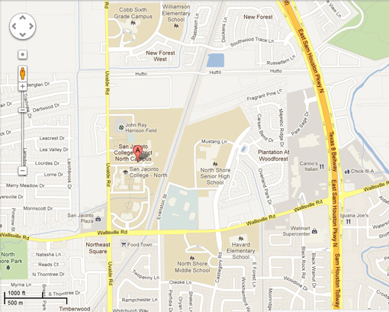](http://www.google.com/maps?f=q&hl=en&geocode=&q=San+Jacinto+College-North,+Houston,+TX+77049,+USA&sll=29.810436,-95.18241&sspn=0.006358,0.007961&ie=UTF8&ll=29.810431,-95.182371&spn=0.006358,0.007961&z=17&iwloc=addr&om=1)

Library

Gymnasium