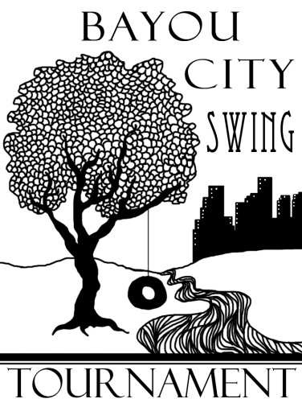

Dear Colleagues:

The forensic programs of Lone Star College – North Harris and San Jacinto College North invite you to the Bayou City Swing, October 23-25, 2015. The swing is open to all intercollegiate competitors. Both halves of the swing will be held on the San Jacinto College North campus. Registration will take place in the Fine Arts Building. The tournament will offer NPDA Debate in addition to all 11 AFA-NIET individual events. Dinner will be provided on Friday evening.

On Friday, 6 rounds of NPDA debate will be offered with quarters (or semis) on Friday as well. Semis (or finals) will be held on Saturday. There will be only one division offered. We will follow all NPDA rules and procedures. WiFi internet access should be available in the building’s common areas.

Saturday and Sunday will each be a self-contained IE tournament, with all 11 AFA-NIET Individual Events. There will be only one division offered. We will follow all AFA rules. No prepared event may have been used in competition prior to this academic year.

**ENTRIES**: Entries will be registered through Joy of Tournaments. The website is www.joyoftournaments.com. Fees will be calculated at 12:00pm on Tuesday October 20th. Adds or drops after 5:00pm on Wednesday October 21st are subject to regular fees as assessed on the 20th plus a $7.00 per change nuisance fee. There is no limit on the number of students a school may enter per event. Students may enter no more than three events per pattern. Students entered in multiple events are responsible for notifying their judges, and judges will not wait past the scheduled times for students who are cross-entered.

**JUDGES:** One judge can cover four (4) individual events slots per pattern for a total of 8 slots across the two patterns. Each debate judge covers two (2) debate teams. A very limited number of hired judges will be available for uncovered slots/teams.

**FEES:** Debate entry fees for the tournament are $50 per Parliamentary Debate team. NPDA judging fees are $75.00 per uncovered team. One judge covers two debate entries. IE entry fees for the tournament are $10.00 per slot per half. Each judge, as previously mentioned, covers four (4) individual event slots per pattern. Hired judges are an additional $12.00 per uncovered slot. Schools which drop judges after Wednesday October 21st at 5:00 PM will incur a $100.00 nuisance fee plus all fees for uncovered slots/teams. *Cash is the vastly preferred for payment of fees*. If you must pay by check, please make checks for both halves of the tournament payable to Wade Hescht.

**LODGING:** We will be using the La Quinta Inn located very conveniently to the campus at 5520 East Sam Houston Pkwy N, Houston, TX 77015 as our tournament hotel. They have guaranteed us a very reasonable rate of $94 per night. Please call 281-452-4402 to make reservations or for further information. Make sure to mention that you are attending the San Jacinto College Speech Tournament. Please bring your tax exemption form if you do not wish to pay state tax.

We look forward to seeing you here in Houston in October!

Respectfully,

Wade Hescht  
Director of Forensics  
Lone Star College – North Harris

Floyd McConnell

Director of Forensics

San Jacinto College North Campus

**2015 Bayou City Swing**

**Tentative Schedule**

**Friday – October 23, 2015**

**11:30 am          Tournament Registration (Fine Arts Building)  
12:30 pm          Rd 1 NPDA   
1:45 pm            Rd 2 NPDA  
3:00 pm            Rd 3 NPDA  
4:15 pm            Rd 4 NPDA  
5:30 pm            Dinner Break (provided by tournament host)  
5:45 pm            Rd 5 NPDA  
7:00 pm            Rd 6 NPDA  
8:15 pm            NPDA Quarterfinals (or Semifinals)**

**Saturday – October 24, 2015**

**7:30 am            IE Registration (Fine Arts Building)  
8:00 am            Extemp Draw  
8:30 am            Rd 1 Pattern A (EXT, POI, PER, DUO, POE, CA)  
9:45 am            Rd 1 Pattern B (IMP, PRO, INF, DI, ADS)  
11:00 am          Extemp Draw  
11:30 am          Rd 2 Pattern A (EXT, POI, PER, DUO, POE, CA)  
12:45 pm          Lunch Break (on your own)  
1:15 pm            Rd 2 Pattern B (IMP, PRO, INF, DI, ADS)  
2:30 pm            Extemp Draw  
3:00 pm            Semis**

**4:15 pm            Finals (Events not advancing to semis)**

**5:30 pm Extemp Draw**

**6:00 pm Finals (All remaining events)**

**7:15 pm NPDA Semifinals   
8:30 pm            Awards Ceremony  
ASAP               NPDA Finals (if necessary)**

**Sunday – October 25, 2015**

**8:00 am            Extemp Draw  
8:30 am            Rd 1 Pattern A (EXT, POI, PER, DUO, POE, CA)  
9:45 am            Rd 1 Pattern B (IMP, PRO, INF, DI, ADS)  
11:00 am          Extemp Draw  
11:30 am          Rd 2 Pattern A (EXT, POI, PER, DUO, POE, CA)  
12:45 pm          Lunch Break (on your own)  
1:15 pm            Rd 2 Pattern B (IMP, PRO, INF, DI, ADS)  
2:30 pm            Extemp Draw  
3:00 pm            Semis   
4:15 pm            Finals (Events not advancing to semis)**

**5:30 pm Extemp Draw**

**6:00 pm Finals (All remaining events)**

**7:15 pm Awards Ceremony**

**San Jacinto College North Campus**

5800 Uvalde  
Houston, TX 77049  
281-998-6150

[Map](http://www.sanjac.edu/sites/default/themeglobal/includes/map.php?campus=n) | [Directions](http://www.google.com/maps?f=q&hl=en&geocode=&q=San+Jacinto+College-North,+Houston,+TX+77049,+USA&sll=29.810436,-95.18241&sspn=0.006358,0.007961&ie=UTF8&ll=29.810431,-95.182371&spn=0.006358,0.007961&z=17&iwloc=addr&om=1" \o "Directions" \t "_blank)

[Printable PDF of campus map with new building codes](http://www.sanjac.edu/sites/default/files/10/Northmap_05_22_13.pdf" \o "North Campus Map Color" \t "_blank)

[Printable PDF of campus map (Black & White)](http://www.sanjac.edu/sites/default/files/10/NorthmapBW_06_04_13.pdf" \o "North Campus Map BW" \t "_blank)

[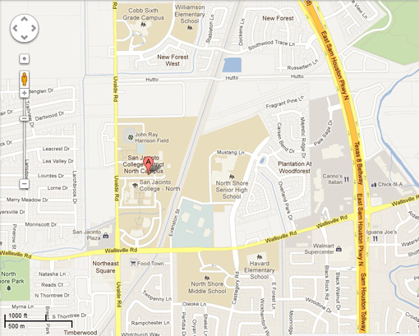](http://www.google.com/maps?f=q&hl=en&geocode=&q=San+Jacinto+College-North,+Houston,+TX+77049,+USA&sll=29.810436,-95.18241&sspn=0.006358,0.007961&ie=UTF8&ll=29.810431,-95.182371&spn=0.006358,0.007961&z=17&iwloc=addr&om=1)

Library

Gymnasium