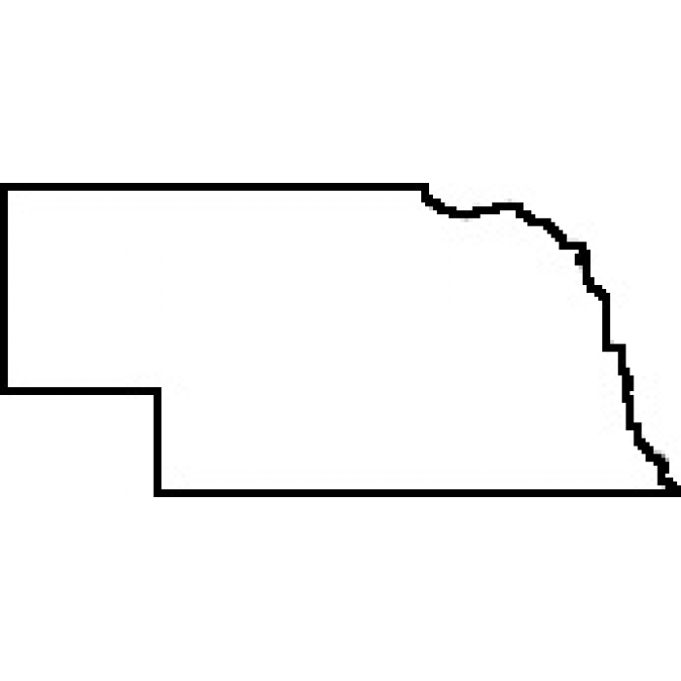

**UNL and UNO Invite You To:**

**The Battle for the Capital Swing**

**February 27 & 28**

January 12th, 2016

Dear Forensics Friends,

When the Nebraska Territory was founded in 1854, Omaha served as its capital city. However, most of Nebraska’s population lived south of the Platte River, sparking vigorous debate about moving the capital city to a location that would serve more people. And so began the Battle for the Capital, or so we like to think, until 1867 when the capital was moved from Omaha to Lincoln.[1]

To honor the history of our state and the friendship between our academic institutions, we invite you to the first annual University of Nebraska Battle for the Capital. **Both days of this swing will be held on the University of Nebraska-Lincoln campus on February 27th & February 28st.** Day one of the tournament will be hosted by UNO and day two will be hosted by UNL.

For several years, UNL and UNO have co-hosted together on the last weekend of the regular season to give teams an opportunity to stretch their budgets**.** To do this, we offer low entry fees of $2 per slot; each uncovered slots will incur an additional $12. Please bring enough usable judges to cover your entry. In order to offer this low entry rate, we will award certificates or similar inexpensive trinkets instead of trophies. Moreover, our judge’s lounge will be modest at best (coffee, bagels, etc.).

**Events and Point Distribution**: We will offer competition in all eleven AFA events and appropriate elimination rounds. AFA tiebreaking procedures will be followed throughout the tournament. Awards will be given for 1st-6th places in each individual event. 1st, 2nd, and 3rd place awards will be given in team sweepstakes. We will also recognize overall team sweepstakes winners.

Points for team awards will be as follows: 10 for 1st, 8 for 2nd, 6 for 3rd, 4 for 4th, 2 for 5th, 1 for 6th. Ties in team sweepstakes will be broken by number of finalists, then number of 1’s, 2’s, 3’s, etc.

**Entry Deadline**: Entries are due Tuesday, February 24th by 5:00 p.m. via www.speechwire.com. Fees will be assessed based on information we have received by February 25h at 12:00 p.m.

**Fees**: A fee of $10 will be charged for all changes made at registration. A fee of $50 will be charged for any judge dropped at registration. Such changes make it difficult to run a timely and efficient tournament. Please try to communicate all changes to the tournament directors ahead of time. **No fee will be charged for events dropped after day one of the swing.**

**Directions to Campus:**

Directions: Tournament registration will be held in UNL’s College of Business Administration (CBA) in room 143. Extemp draw will be in CBA 24. The College of Business Administration is located at approximately 12th and R street in Lincoln.

.

Visit this website for a map of Lincoln and the UNL campus: <http://maps.unl.edu/>

*Special Needs: If you have a student or coach with special needs, please let us know. We will be happy to provide accommodations.

**Tournament Schedule (Same for both days):**

We will offer all eleven AFA individual events on both days.

8:00    Registration (first floor of AS)

8:30   Extemp Draw

8:45    Round 1A (Duo, CA, Extemp, Info, POI, Prose)

10:00    Round 1B (ADS, DI, Impromptu, Persuasion, Poetry)

11:15   Lunch

11:45    Extemp Draw

12:00    Round 2A

 1:15    Round 2B

 2:30    Extemp Draw

2:45 Finals A

 3:45    Finals B

ASAP   Awards

We will send out an information pack the week of the tournament with food options and information regarding important rooms, including judges’ lounge and extemp draw.

Cameron Logsdon Aaron Duncan

Assistant Director of Forensics Director of Forensics

University of Nebraska Omaha University of Nebraska Lincoln

(402) 709-2361 (402) 472-6920

cameronlogsdon@gmail.com aduncan3@unl.edu

1. For you history buffs, the capital was moved from Omaha to the village of Lancaster. Lancaster was not renamed “Lincoln” until Nebraska was admitted to the union on March 1, 1867.